|  |
| --- |
|  |
| The Documentation |
| [Type the document subtitle] |
|  |
| **[Your Name]** |
| **[Pick the date]** |

[Type the abstract of the document here. The abstract is typically a short summary of the contents of the document. Type the abstract of the document here. The abstract is typically a short summary of the contents of the document.]

Table of Contents

[To update the table of contents, right click the message below and select Update Field (F9 on PC, ⌥⌘U on Mac).]

**No table of contents entries found.**

1. Pages
   1. Page Tree

Wireframes  
 Automated Sitemap  
 0.1 Sign Up  
 FB  
 Email  
 G+  
 Sign In  
 1.0 Home  
 2.0 Kid Profile  
 2.1 Ruler  
 2.2 Filter  
 3.0 Product List View  
 3.1 Map View  
 3.2 List View  
 3.3 Product Detail  
 3.4 Settings  
Documentation  
 WBS  
 Task Flows  
 Sitemap  
 resources  
Copy of Wireframes  
 Sign Up  
 Home  
 Kid Profile  
 Ruler  
 Filter  
 Product List View  
 List View  
 Map View  
 Product Detail  
 Settings  
New Sitemap

* 1. Automated Sitemap
     1. User Interface

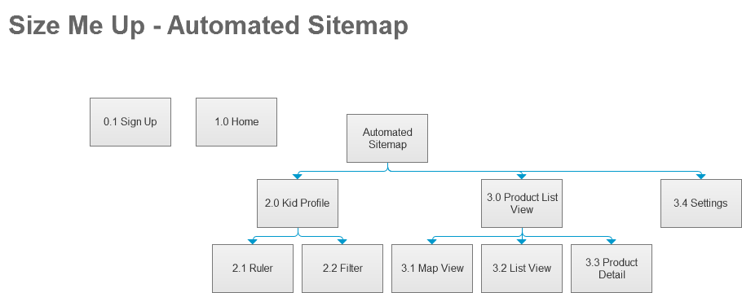

* 1. 0.1 Sign Up

**Note 1** - You can also write page notes here

- Lorem ipsum dolor sit amet, consectetur adipiscing elit.

- Aenean euismod bibendum laoreet. Proin gravida dolor sit amet lacus accumsan et viverra justo commodo.

- Proin sodales pulvinar tempor. Cum sociis natoque penatibus et magnis dis parturient montes, nascetur ridiculus mus.

- Nam fermentum, nulla luctus pharetra vulputate, felis tellus mollis orci, sed rhoncus sapien nunc eget odio.

**Note 2** - something else

**Note 3** - A third thing

* + 1. User Interface

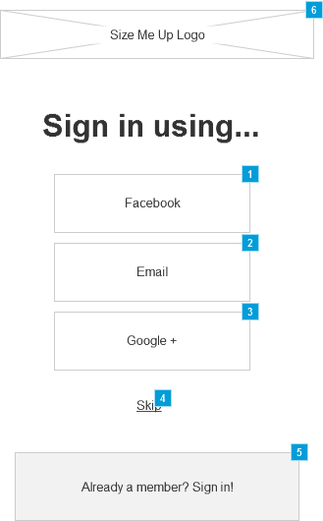

* + 1. Widget Table

| Footnote | Name | Interactions | Note |
| --- | --- | --- | --- |
| 1 | Facebook Option | OnClick:  Case 1:  Open FB in Current Window |  |
| 2 | Email Option | OnClick:  Case 1:  Open Email in Current Window |  |
| 3 | Google Option | OnClick:  Case 1:  Open G+ in Current Window |  |
| 4 | Skip | OnClick:  Case 1:  Open 2.1 Ruler in Current Window |  |
| 5 | Sign In | OnClick:  Case 1:  Open Sign In in Current Window |  |
| 6 | SMU Logo |  | The logo goes here and I can write a note about it. |

* 1. FB

A note about FB page

A second note

A third note

* 1. Email
  2. G+
  3. Sign In
  4. 1.0 Home
     1. User Interface

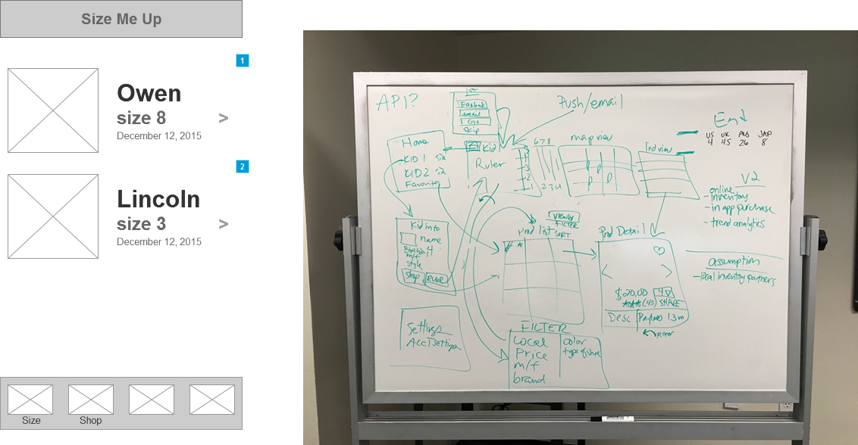

* + 1. Widget Table

| Footnote | Name | Interactions |
| --- | --- | --- |
| 1 | kid 1 block | OnClick:  Case 1:  Open 2.0 Kid Profile in Current Window OnSwipeLeft:  Case 1:  Open 2.0 Kid Profile in Current Window |
| 2 | kid 2 block | OnClick:  Case 1:  Open 2.0 Kid Profile in Current Window OnSwipeLeft:  Case 1:  Open 2.0 Kid Profile in Current Window |

* + 1. kid 1 block
       1. State1
       2. User Interface

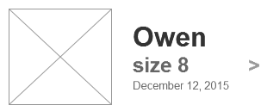

* + 1. kid 2 block
       1. State1
       2. User Interface

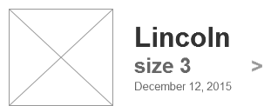

* 1. 2.0 Kid Profile
     1. User Interface

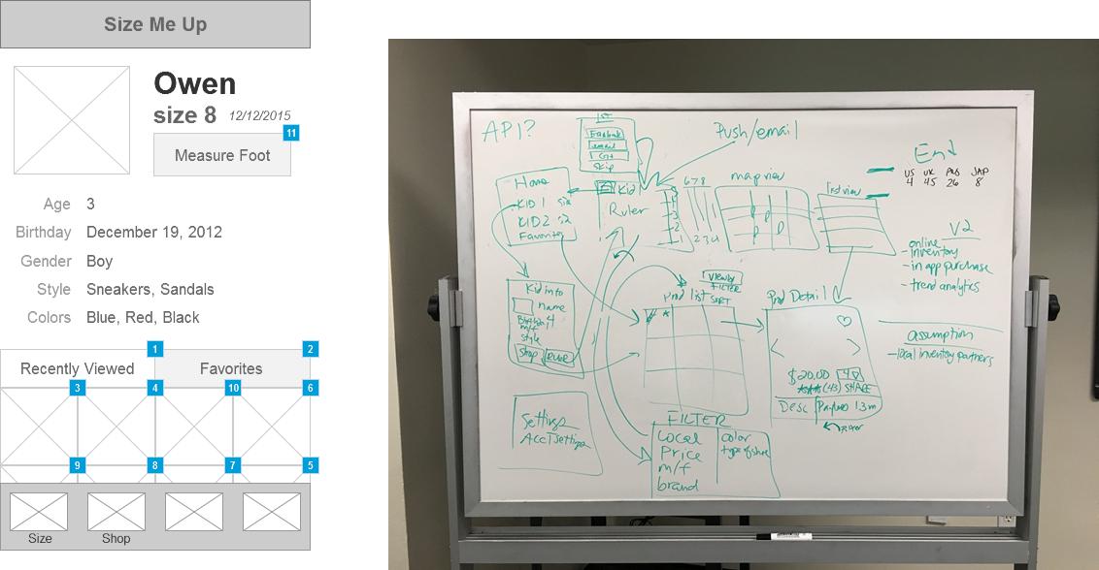

* + 1. Widget Table

| Footnote | Name | Interactions | Note |
| --- | --- | --- | --- |
| 1 | Recently Viewed tab |  | All shoes that the user has looked at the product detail of. |
| 2 | Favorites Tab |  | All shoes that the user has marked as a favorite. |
| 3 | image of shoe | OnClick:  Case 1:  Open 3.3 Product Detail in Current Window |  |
| 4 | image of shoe | OnClick:  Case 1:  Open 3.3 Product Detail in Current Window |  |
| 5 | image of shoe | OnClick:  Case 1:  Open 3.3 Product Detail in Current Window |  |
| 6 | image of shoe | OnClick:  Case 1:  Open 3.3 Product Detail in Current Window |  |
| 7 | image of shoe | OnClick:  Case 1:  Open 3.3 Product Detail in Current Window |  |
| 8 | image of shoe | OnClick:  Case 1:  Open 3.3 Product Detail in Current Window |  |
| 9 | image of shoe | OnClick:  Case 1:  Open 3.3 Product Detail in Current Window |  |
| 10 | image of shoe | OnClick:  Case 1:  Open 3.3 Product Detail in Current Window |  |
| 11 | Ruler button | OnClick:  Case 1:  Open 2.1 Ruler in Current Window |  |

* 1. 2.1 Ruler
  2. 2.2 Filter
  3. 3.0 Product List View
  4. 3.1 Map View
  5. 3.2 List View
  6. 3.3 Product Detail
  7. 3.4 Settings
  8. WBS
     1. User Interface

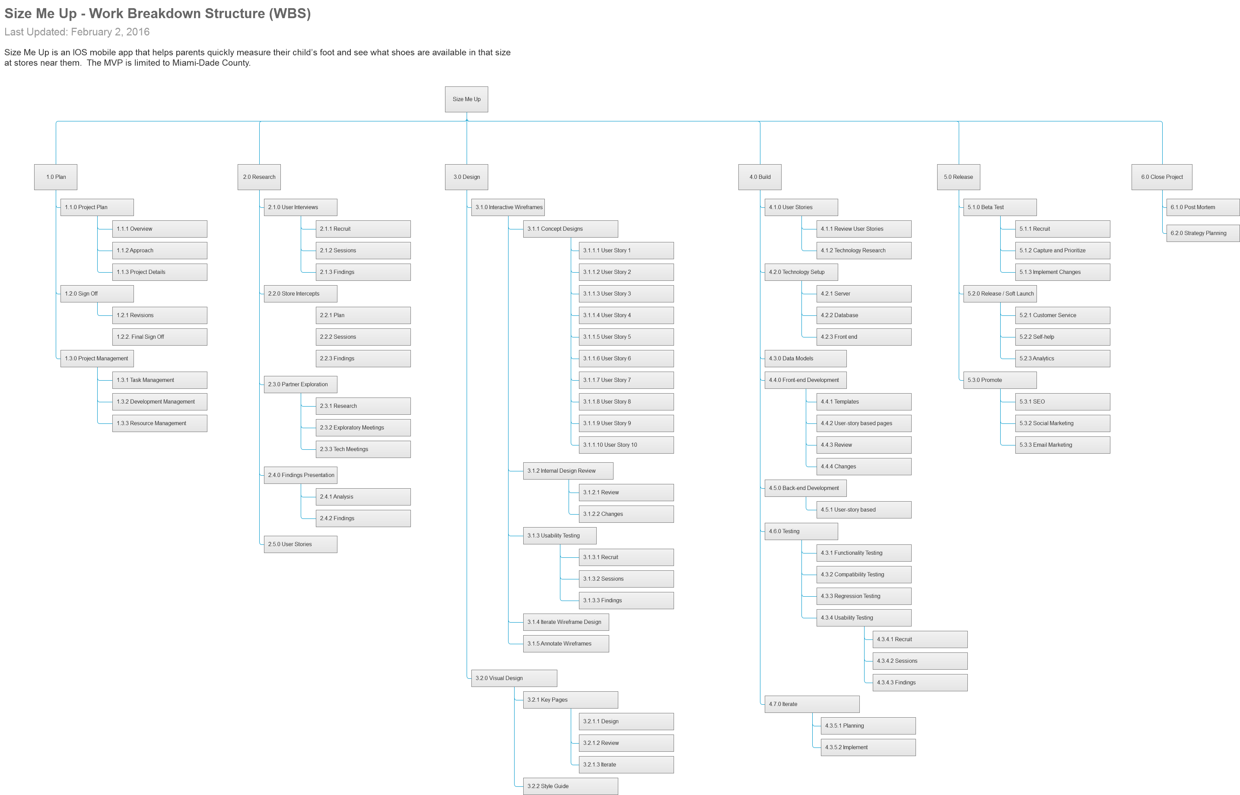

* 1. Task Flows
     1. User Interface

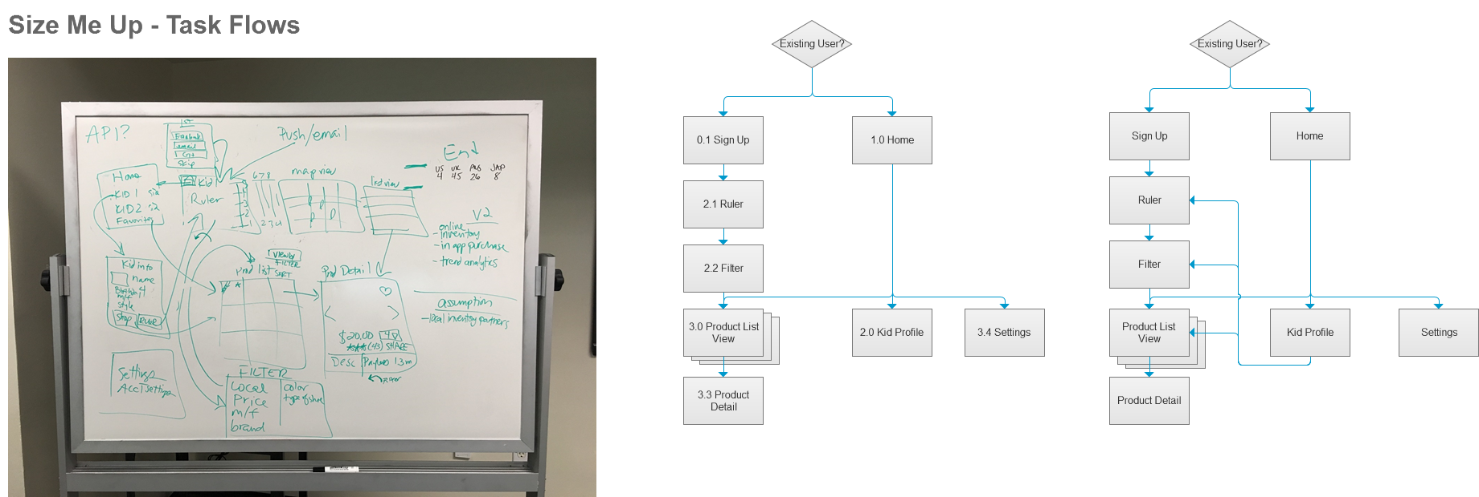

* 1. Sitemap
     1. User Interface

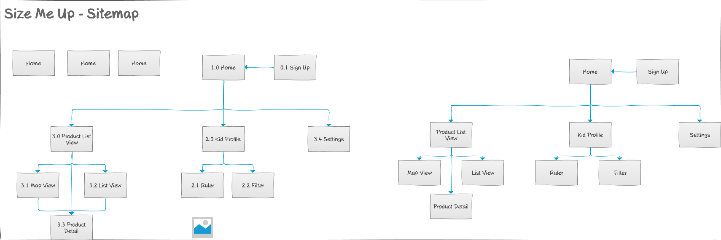

* 1. resources
     1. User Interface



* + 1. Widget Table

| Footnote | Interactions |
| --- | --- |
| 1 | OnClick:  Case 1:  Open http://www.paintcodeapp.com/news/ultimate-guide-to-iphone-resolutions in Current Window |

* 1. Sign Up
     1. User Interface



* 1. Home
     1. User Interface

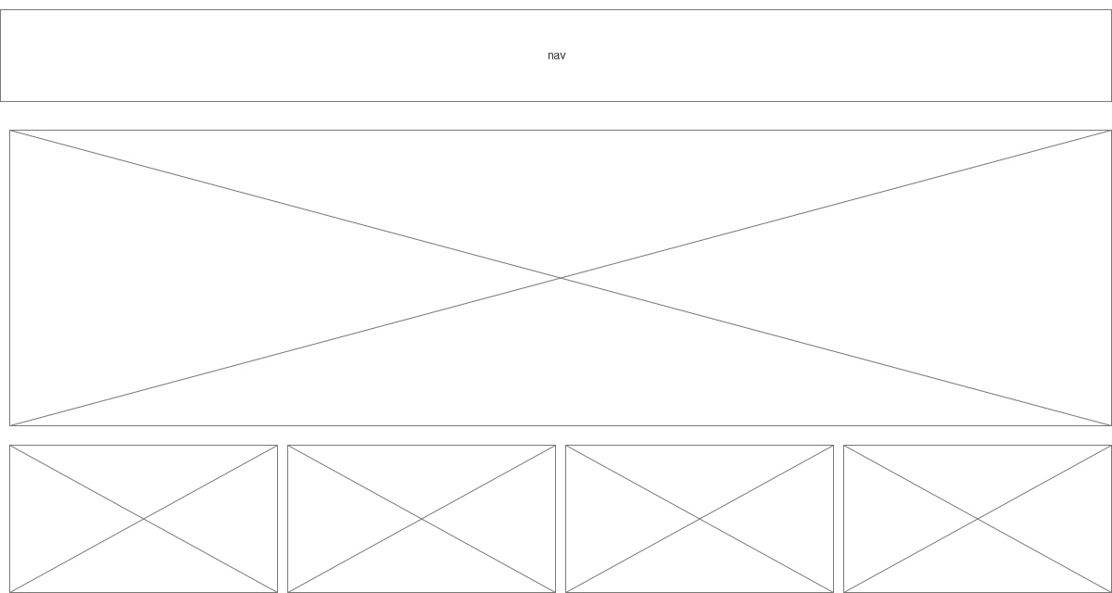

* 1. Kid Profile
  2. Ruler
  3. Filter
  4. Product List View
     1. User Interface

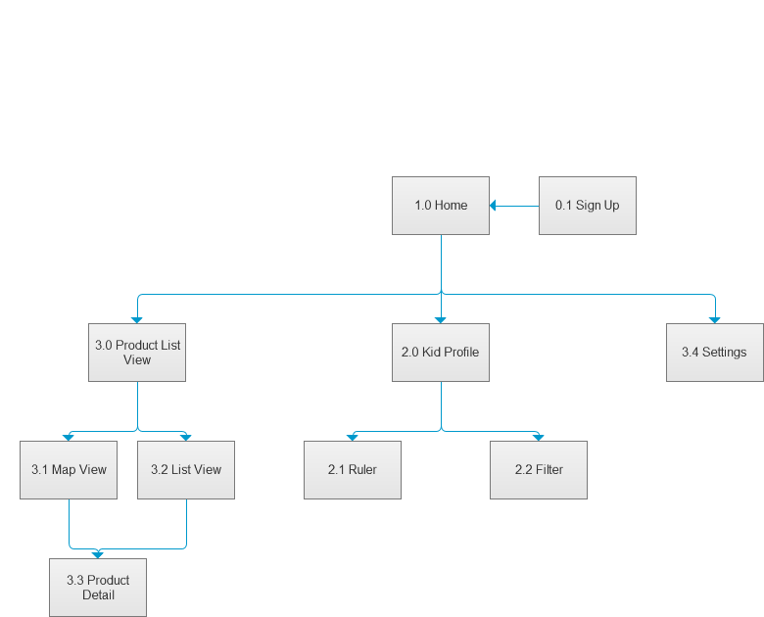

* 1. List View
  2. Map View
  3. Product Detail
  4. Settings
  5. New Sitemap

1. Masters
   1. Master List

Responsive Header Example  
Header  
Footer

* 1. Responsive Header Example
     1. User Interface



* 1. Header
     1. User Interface



* 1. Footer
     1. User Interface



* + 1. tab bar
       1. State1
       2. User Interface



* + - 1. Widget Table

| Footnote | Name | Interactions | Note |
| --- | --- | --- | --- |
| 1 |  | OnClick:  Case 1:  Open 2.1 Ruler in Current Window | Link to ruler |
| 2 |  | OnClick:  Case 1:  Open 3.0 Product List View in Current Window | Link to Product List View |